Different Aspects of Event Loop

***Topics are discussed in no particular order, and are a collection of snippets from various sources and my understanding of the same.***

Timer queue is actually a priority queue implemented with a min heap by libuv.

So, in accordance with the structure of a min-heap, the element with the min value always stays at the top and therefore at any point in time the first element in the queue(root element in the min heap) is the element with the min value.

The value of each element in this timer-queue of event loop is the time at which it expires. So for example, if you have set a timeout with the duration being 500 milliseconds, then the the value of that element in the timer queue would be the current time + 500ms. So, by design the timeouts closest to expiry would be at the start of the queue(top of the heap).

At the timers phase of the event loop, Node will check the timers heap for expired timers/intervals and will call their callbacks respectively.

SetInterval works in a similar manner in the sense that after each execution of it, a new element with a timestamp having the value of current time plus interval duration is added back to the queue.

**Node uses libuv underneath to take care of this. While setTimeout has some internal managing of its own, it ends up using the *uv\_timer\_t* facility provided by libuv.**

**Let’s assume that the only thing the event loop is doing is the timer. libuv will calculate the poll timeout, which will actually be the timer's due time (in this example). Then the event loop will block for i/o by using the appropriate syscall (*epoll\_wait, kevent, etc*). At that point it's up to the kernel to decide what to do, but the current thread of execution is blocked until the kernel wakes it up again, so there is no used CPU here, because nothing is happening.**

**Once the timeout expires, the aforementioned syscall will return, and libuv will process the due timers and i/o.**

In simpler terms, the timer would be first set, then the event loop would wait for any I/O in the next phase until the timer expires in which case it would loop through the remaining phases of the current loop to reach the timer phase again where it would execute the expired timer callbacks.

**If an immediate timer is queued from inside an executing callback, that timer will not be triggered until the next event loop iteration.**

**Bindings**: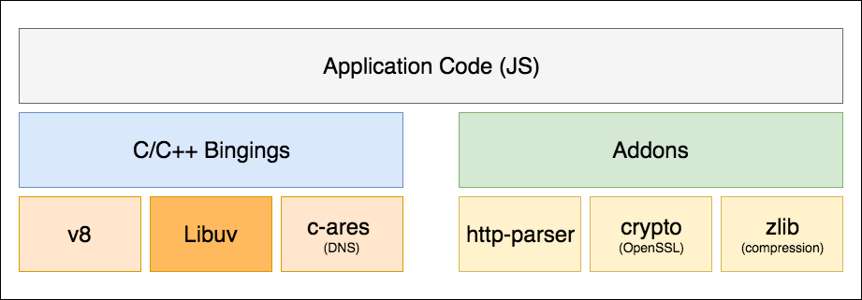

Normally code written in different languages cannot communicate with each other. Not without bindings. Bindings, as the name implies, are glue codes that “bind” one language with another so that they can talk with each other. In this case (Node.js), bindings simply expose core Node.js internal libraries written in C/C++ (V8, Libuv, c-ares, zlib, OpenSSL, http-parser, etc.) to JavaScript. One motivation behind writing bindings is code reuse: if a desired functionality is already implemented, why write the entire thing again, just because they are in different languages? Why not just bridge them? Another motivation is performance: system programming languages such as C/C++ are generally much faster than other high-level languages (e.g. Python, JavaScript, Ruby, etc.). Therefore it might be wise to designate CPU-intensive operations to codes written in C/C++, for example.

**C/C++ Addons**: Bindings only provide glue code for Node.js’ core internal libraries, i.e. zlib, OpenSSL, c-ares, http-parser, etc. If you want to include a third-party or your own C/C++ library in your application, you would have to write the glue code for that library yourself. These glue code you write are called addons. Think of bindings and addons as **bridges** between your JavaScript code and Node.js’ C/C++ code.

A brief explanation of how the node ecosystem works with bindings for fs.readFile

<https://github.com/libuv/help/issues/62#issuecomment-424431606>

When the event loop enters the **poll** phase,

*If the****poll****queue****is not empty***, the event loop will iterate through its queue of callbacks executing them synchronously until either the queue has been exhausted, or the system-dependent hard limit is reached. By default, it will keep on waiting at this stage for any pending IO operations to complete (for example, a fs.readFile() has not completed yet)

Now, if a timer is set it would wait for the maximum time until the soonest timer's threshold is reached, after which it would wrap back to the **timers** phase to execute those timers' callbacks. During this wait time for a set timer to expire, if other callback(s) are added to the poll queue, then it would start executing them. So the event loop would only reach the timer phase only after all the callbacks in the poll queue have been executed. [Consider the scenario of waiting on http request, if there are no other tasks to be executed by the event loop then it keeps on waiting at this phase for request, that’s why the event loop remains active and the node process doesn’t exit. And even if some other tasks come through, say a timer has expired it would run those tasks as per the set algorithm and then would again come back to this busy waiting phase].

And finally irrespective of a timer being set or not, if ***the poll queue becomes empty***, and if there are scripts that have been scheduled by setImmediate(), then the event loop will end the poll phase and continue to the ***check phase*** to execute those scheduled scripts.

**check**

This phase allows a person to execute callbacks immediately after the **poll** phase has completed. If the **poll** phase becomes idle and scripts have been queued with setImmediate(), the event loop may continue to the **check** phase rather than waiting.

setImmediate() is actually a special timer that runs in a separate phase of the event loop. It uses a libuv API that schedules callbacks to execute after the **poll** phase has completed.

Generally, as the code is executed, the event loop will eventually hit the **poll** phase where it will wait for an incoming connection, request, etc. However, if a callback has been scheduled with setImmediate() and the **poll** phase becomes idle, it will end and continue to the **check** phase rather than waiting for **poll** events.

**close callbacks**

If a socket or handle is closed abruptly (e.g. socket.destroy()), the 'close' event will be emitted in this phase. Otherwise it will be emitted via process.nextTick().

A real world use-case for *Process.nextTick()*:

*const server = net.createServer(() => {}).listen(8080);*

*server.on('listening', () => {});*

When only a port is passed, the port is bound immediately. So, the 'listening' callback could be called immediately. The problem is that the *.on('listening')* callback will not have been set by that time.

To get around this, the 'listening' event is queued in a nextTick() to allow the script to run to completion. This allows the user to set any event handlers they want.

There are two main reasons as to why someone would use *nextTick()* over *setImmediate()*:  
1. Allow users to handle errors, cleanup any then unneeded resources, or perhaps try the request again before the event loop continues.  
2. At times it's necessary to allow a callback to run after the call stack has unwound but before the event loop continues.

An OS maintains a list of PCB – Process control block, which is a structure that holds the context for each of it’s own processes.

Each process has it’s own PCB.

A PCB has a file descriptor table. Each row in that table has a file descriptor no (index), and a pointer to the “file structure” for the concerned resource.

A “file structure” stores the details to the location of the resource.  
A “resource” can be a file, socket, terminal, pipes, devices.  
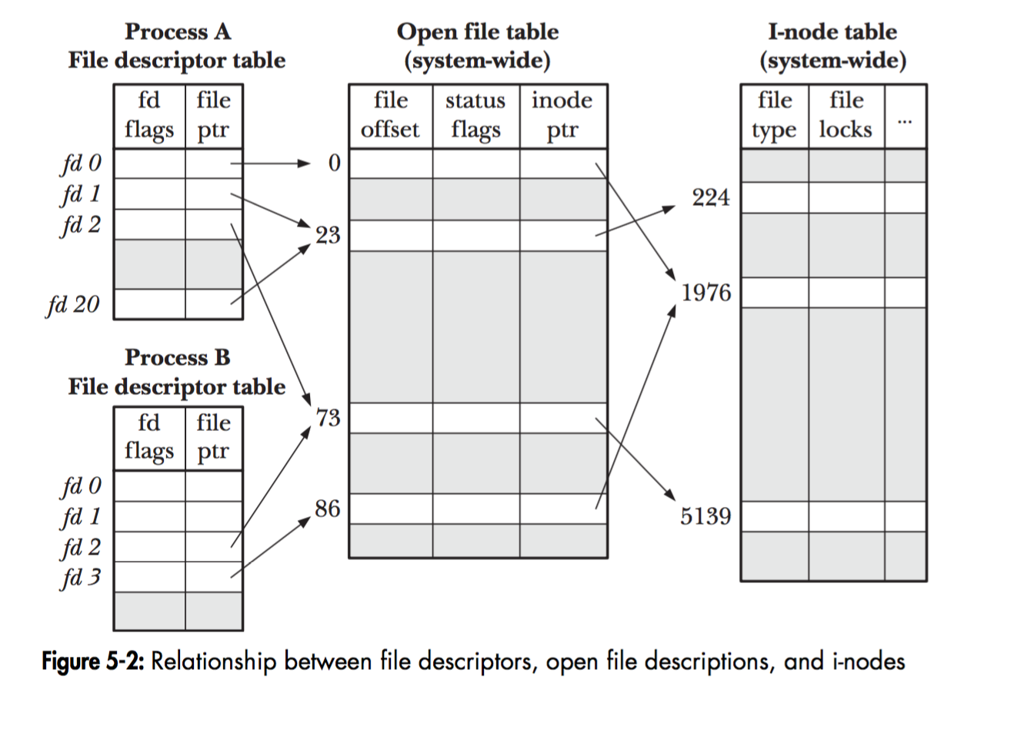

Between each phase, libuv needs to communicate the results of the phase [If it’s an IO phase, then the to the higher layers of Node architecture (which means JavaScript). Each time this happens, any *process.nextTick* callbacks and other microtask callbacks will be executed.

In truth, the Event Loop does not actually maintain a queue. Instead, it has a collection of file descriptors that it asks the operating system to monitor, using a mechanism like [epoll](http://man7.org/linux/man-pages/man7/epoll.7.html) (Linux), [kqueue](https://developer.apple.com/library/content/documentation/Darwin/Conceptual/FSEvents_ProgGuide/KernelQueues/KernelQueues.html) (OSX), event ports (Solaris), or [IOCP](https://msdn.microsoft.com/en-us/library/windows/desktop/aa365198.aspx) (Windows). These file descriptors correspond to network sockets, any files it is watching, and so on. When the operating system says that one of these file descriptors is ready, the Event Loop translates it to the appropriate event and invokes the callback(s) associated with that event.

**(1) Who put callback function to event queue?**

Node.js is a libuv "embedder". Node.js uses libuv for (1) platform-independent (asynchronous) system call support, and (2) its event loop / worker pool paradigm.

See *nodejs/src/node.cc::Start* for the call to uv\_run that drives the libuv event loop that Node.js uses.

This enters (in Linux) *libuv/src/unix/core.c* where *uv\_run* is defined. Note the call to *uv\_\_io\_poll* within which heads over to *libuv/src/unix/linux-core.c* where *epoll\_pwait* is issued.

**(2) And is there really only callback function in event queue? how about result of I/O Operation - The value which will be used in callback function as a argument value?**

Everything the libuv event loop handles is a "callback". But the callbacks the libuv event loop invokes (function pointers) are not always the same as the callbacks in Node.js (JavaScript code). Node.js sometimes (always?) interposes [places itself between] its own C++ code as callbacks. For example, *fs.readFile* is converted by Node.js into several *uv\_fs\_X* operations under the hood, and only after stat, open, potentially many read's, and close will the user's JS callback be invoked. Each of those FS operations runs asynchronously and spends some time on the event loop. C++-land Node.js libraries (and I believe the code re-enters the JS fs library along the way?) manage all that for you.

To see how code moves from Node.js JavaScript into Node.js C++, take a look for example *at node/src/node\_file.cc::Initialize*. These calls tell V8 how to map from JS calls into the appropriate Node.js C++ bindings.

When it comes to libuv, there are 7 distinguishable phases. They are,

**Timers** — Expired timer and interval callbacks scheduled by setTimeout and setInterval will be invoked.

**Pending I/O callbacks** — Pending Callbacks of any completed/errored I/O operation to be executed here.

Idle **handlers** — Perform some libuv internal stuff.

Prepare **Handlers** — Perform some prep-work before polling for I/O.

I/O Poll — Optionally wait for any I/O to complete.

Check **handlers** — Perform some post-mortem work after polling for I/O. Usually, callbacks scheduled by setImmediate will be invoked here.

Close **handlers** — Execute close handlers of any closed I/O operations (closed socket connection etc.)

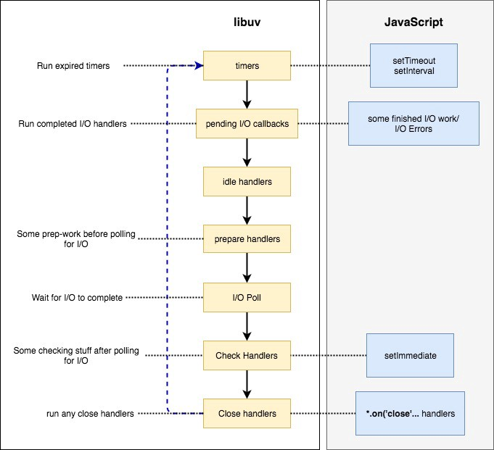

The complete IO related phases. Handling pending, waiting, executing, pre/post work

The I/O action comprises of: *Execute pending callbacks - Idle – Pre-poll I/O Prepare – I/O Poll – Post-poll Check*

**Design overview — libuv documentation**

**Design overview**

libuv is cross-platform support library which was originally written for [Node.js](https://nodejs.org/). It’s designed around the event-driven asynchronous I/O model.

The library provides much more than a simple abstraction over different I/O polling mechanisms: ***‘handles’*** and ***‘streams’*** provide a high level abstraction for sockets and other entities; cross-platform file I/O and threading functionality is also provided, amongst other things.

Here is a diagram illustrating the different parts that compose libuv and what subsystem they relate to:

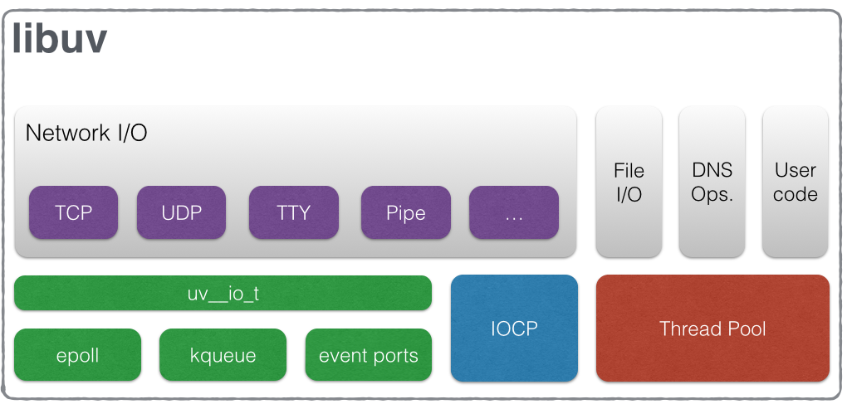

**Handles and requests**

libuv provides users with 2 abstractions to work with, in combination with the event loop: handles and requests.

Handles represent long-lived objects capable of performing certain operations while active. Some examples:

* A prepare handle gets its callback called once every loop iteration when active.
* A TCP server handle that gets its connection callback called every time there is a new connection.

Requests represent (typically) short-lived operations. These operations can be performed over a handle: write requests are used to write data on a handle; or standalone: getaddrinfo requests don’t need a handle they run directly on the loop.

**The I/O loop**

The I/O (or event) loop is the central part of libuv. It establishes the content for all I/O operations, and it’s meant to be tied to a single thread. One can run multiple event loops as long as each runs in a different thread. The libuv event loop (or any other API involving the loop or handles, for that matter) **is not thread-safe** except where stated otherwise.

The event loop follows the rather usual single threaded asynchronous I/O approach: all (network) I/O is performed on non-blocking sockets which are polled using the best mechanism available on the given platform: epoll on Linux, kqueue on OSX and other BSDs, event ports on SunOS and IOCP on Windows. As part of a loop iteration the loop will block waiting for I/O activity on sockets which have been added to the poller and callbacks will be fired indicating socket conditions (readable, writable hangup) so handles can read, write or perform the desired I/O operation.

In order to better understand how the event loop operates, the following diagram illustrates all stages of a loop iteration:

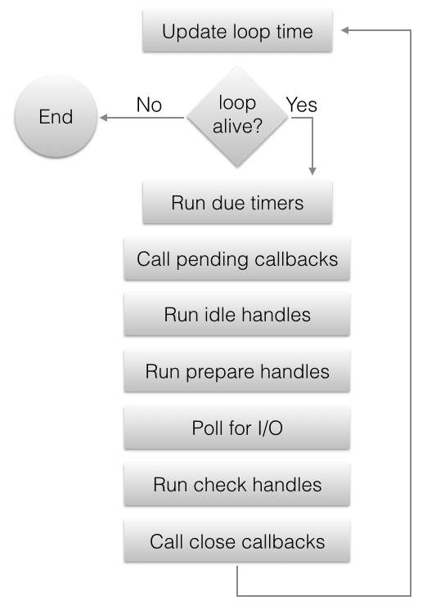

1. The loop concept of ‘now’ is updated. The event loop caches the current time at the start of the event loop tick in order to reduce the number of time-related system calls.
2. If the loop is *alive* an iteration is started, otherwise the loop will exit immediately. So, when is a loop considered to be *alive*? If a loop has active and ref’d handles, active requests or closing handles it’s considered to be *alive*.
3. Due timers are run. All active timers scheduled for a time before the loop’s concept of *now* get their callbacks called.
4. Pending callbacks are called. All I/O callbacks are called right after polling for I/O, for the most part. There are cases, however, in which calling such a callback is deferred for the next loop iteration. If the previous iteration deferred any I/O callback it will be run at this point.
5. Idle handle callbacks are called. Despite the unfortunate name, idle handles are run on every loop iteration, if they are active.
6. Prepare handle callbacks are called. Prepare handles get their callbacks called right before the loop will block for I/O.
7. Poll timeout is calculated. Before blocking for I/O the loop calculates for how long it should block. These are the rules when calculating the timeout:
   * If the loop was run with the UV\_RUN\_NOWAIT flag, the timeout is 0.
   * If the loop is going to be stopped ([uv\_stop()](http://docs.libuv.org/en/v1.x/loop.html" \l "c.uv_stop" \o "uv_stop) was called), the timeout is 0.
   * If there are no active handles or requests, the timeout is 0.
   * If there are any idle handles active, the timeout is 0.
   * If there are any handles pending to be closed, the timeout is 0.
   * If none of the above cases matches, the timeout of the closest timer is taken, or if there are no active timers, infinity.
8. The loop blocks for I/O. At this point the loop will block for I/O for the duration calculated in the previous step. All I/O related handles that were monitoring a given file descriptor for a read or write operation get their callbacks called at this point.
9. Check handle callbacks are called. Check handles get their callbacks called right after the loop has blocked for I/O. Check handles are essentially the counterpart of prepare handles.
10. Close callbacks are called. If a handle was closed by calling [uv\_close()](http://docs.libuv.org/en/v1.x/handle.html" \l "c.uv_close" \o "uv_close) it will get the close callback called.
11. Special case in case the loop was run with UV\_RUN\_ONCE, as it implies forward progress. It’s possible that no I/O callbacks were fired after blocking for I/O, but some time has passed so there might be timers which are due, those timers get their callbacks called.
12. Iteration ends. If the loop was run with UV\_RUN\_NOWAIT or UV\_RUN\_ONCE modes the iteration ends and [uv\_run()](http://docs.libuv.org/en/v1.x/loop.html" \l "c.uv_run" \o "uv_run) will return. If the loop was run with UV\_RUN\_DEFAULT it will continue from the start if it’s still *alive*, otherwise it will also end.

Important

libuv uses a thread pool to make asynchronous file I/O operations possible, but network I/O is **always** performed in a single thread, each loop’s thread.

Note

While the polling mechanism is different, libuv makes the execution model consistent across Unix systems and Windows.

**File I/O**

Unlike network I/O, there are no platform-specific file I/O primitives libuv could rely on, so the current approach is to run blocking file I/O operations in a thread pool.

For a thorough explanation of the cross-platform file I/O landscape, checkout [this post](http://blog.libtorrent.org/2012/10/asynchronous-disk-io/).

libuv currently uses a global thread pool on which all loops can queue work. 3 types of operations are currently run on this pool:

* File system operations
* DNS functions (*getaddrinfo* and *getnameinfo*)
* User specified code via [uv\_queue\_work()](http://docs.libuv.org/en/v1.x/threadpool.html" \l "c.uv_queue_work" \o "uv_queue_work)

Two things to keep in mind regarding setImmediate in the check phase of the loop :

* If the **poll** phase becomes idle and scripts have been queued with setImmediate(), the event loop may continue to the **check** phase rather than waiting.
* If an immediate timer is queued from inside an executing callback, that timer will not be triggered until the next event loop iteration